**­­­**

Class 8

**Lecture \***

**Digital Electronics**

**(Number System- Conversion-II)**

**Digital Electronics**



**Lab Objectives:**

* Number System Conversion-II.

**Number System Conversions**

There are three types of conversion:

**Decimal Number System to Other Base**

[for example: Decimal Number System to Binary Number System]

**Other Base to Decimal Number System**

[for example: Binary Number System to Decimal Number System]

**Other Base to Other Base**

[for example: Binary Number System to Hexadecimal Number System]

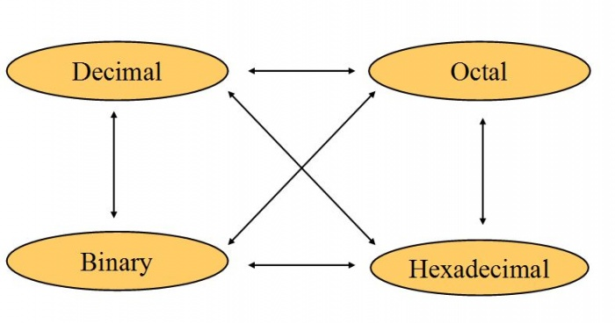

**Other Base System to Decimal Number Base**

To convert Number System from Any Other Base System to Decimal Number System, you have to follow just three steps:

A) Determine the base value of source Number System (that you want to convert), and also determine the position of digits from LSB (first digit’s position – 0, second digit’s position – 1 and so on).

B) Multiply each digit with its corresponding multiplication of position value and Base of Source Number System’s Base.

C) Add the resulted value in step-B.

**Binary to Decimal**

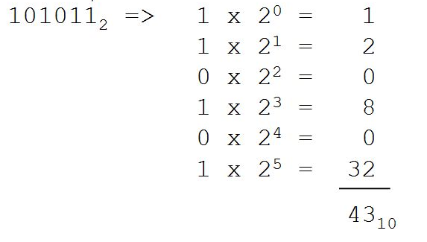

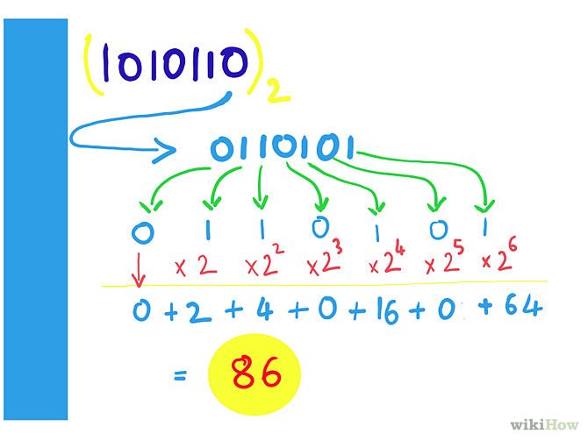

**Octal to Decimal**

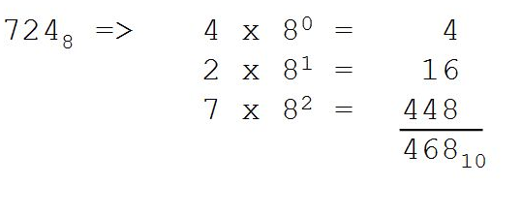

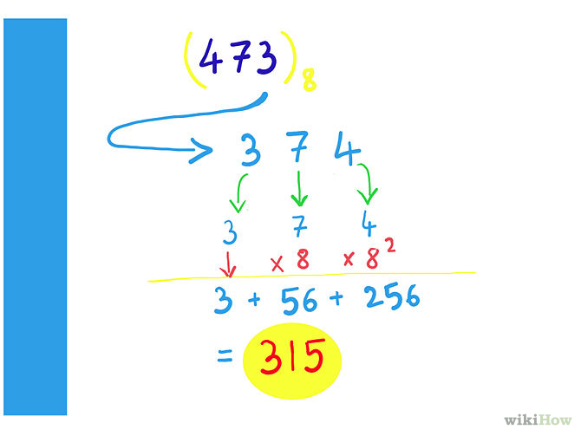

**Hexadecimal to Decimal**

